Mailed 01/10/2000
Decision 00-01-015 January 06, 2000

BEFORE THE PUBLIC UTILITIES COMMISSION OF THE STATE OF CALIFORNIA

Application of the Santa Clara County Transit District (CIS 110.01.4) for an order authorizing construction of an at-grade crossing with installation of two (2) flashing lights and gates (Standard No. 9) and two (2) cantilever flashing lights and gates (Standard No. 9A) across Central Expressway by the Light Rail Transit line of the Tasman Corridor Project in the City of Mountain View, County of Santa Clara. | Application 94-12-018  (Filed December 5, 1994) (Amended November 10, 1999)

OPINION

As part of the Tasman Corridor Project, the Santa Clara Valley Transportation Authority (VTA), formerly the Santa Clara Transit District, requests authority to modify the at-grade, heavy-rail crossing of Central Expressway (Crossing 001E-36.90-C) in the City of Mountain View (City), County of Santa Clara (County). Proposed modifications will reconstruct the crossing to accommodate light-rail operations.
The Tasman Corridor Project is a multi-modal transportation facility approximately 12 miles in length, between the cities of Mountain View and San Jose. Once completed, this facility will provide public transportation in conjunction with existing light-rail, commuter rail, and bus systems, in the Santa Clara area. Central Expressway is on an east-west alignment within the City of Mountain View, towards the south portion of the Tasman Corridor. The existing track runs parallel to Central Expressway on the south, then curves north through the roadway.
At present, the Union Pacific Railroad (UP) operates freight trains through the subject crossing by request of the NASA Ames Research Center. The crossing characteristics are as follows: 100 foot overall width, four- lane, single track on 425 foot radius curve, angle range from 19 degrees (at eastbound edge of pavement) to 44 degrees (at westbound edge of pavement) roadside bike lanes (8 feet each), 36 foot wide landscaped median, asphaltic concrete surface, two CPUC Std. No. 9 automatic gate type signals, and two CPUC Std, No. 8 automatic flashing light type signals.
The project proposes to reconstruct the existing crossing to accommodate light-rail operations, and modify the roadway configuration for increased capacity. Proposed changes to the existing conditions are: 110 foot overall width, six-lane, roadside bike lanes (6 feet each), 16 foot wide median with limited landscaping, concrete panel surface, two CPUC Std. No. 9-A automatic gate type signals with cantilever, two CPUC Std. No. 9 automatic gate type signals, and on the westbound approach one automatic advanced warning sign (Caltrans Type 9B fitted with W47 sign). A sketch of the proposed crossing is attached as Appendix A.
In addition, the project proposes to install one positive-barrier gate on the westbound approach in advance of the standard crossing gates and cantilever. The positive-barrier gate operates like, and has the general appearance of, the CPUC Std. No. 9 automatic gate. However, when activated, it is designed to physically prevent the intrusion of a motor vehicle onto the track way. This is accomplished by way of three energy-absorbing, steel cables mounted within the aluminum framework of the gate. When in the horizontal position, the gate (along with its cables) extends across the westbound lanes of Central Expressway. It becomes pinned at concrete foundations located on either side of the westbound lanes, thus providing resistance to intrusion. It is manufactured by B&B Electromatic, based in Norwood, LA. A description and drawing is set forth as Appendix B. The County will install a traffic signal in advance of the positive-barrier gate. The purpose of this signal is to notify vehicular traffic to stop because of the temporary road closure rather than alternatively giving the right-of-way to conflicting traffic movements. This is consistent with the Manual on Uniform Traffic Control Devices (MUTCD), Sections 4E-13 through 4E-17, 1988 Edition.
The installation of the positive-barrier gate is a result of much decision and negotiation between all parties involved. In brief, it serves to mitigate the limited sight-triangle of the northeast quadrant of the crossing. At present, a residential subdivision occupies the space directly north of Central Expressway and east of the Tasman alignment. The subdivision comprises two-story homes surrounded by a sound wall that has an approximate height of 8 feet. This obstructs the view between westbound vehicles and southbound trains, thus limiting the sight-triangle of the northeast quadrant.
Since the installation of a positive-barrier gate at a railroad crossing is unprecedented in California, it should be authorized on a trail/demonstration basis. Once installed, VTA should monitor, evaluate, and report the performance of the positive-barrier gate system. VTA should submit a 6-Month Preliminary Report, a 1-Year Final Report, and 1-Month Post Incident Reports as defined in Appendix C of this decision. If at any time, the positive barrier-gate system is deemed insufficient, inadequate, or unsafe, and subsequently removed from operation, VTA shall mitigate hazards associated with the limited sight-triangle in order to maintain operations across Central Expressway.
VTA is the lead agency for this project under the California Environmental Quality Act of 1970 (CEQA), as amended, Public Resources (PR) Code Sections 21000, et seq. After preparation and review of an Environmental Impact Report (EIR), VTA approved the project. On January 12, 1993, VTA filed a Notice of Determination (NOD) with the County Clerk of Santa Clara stating that “the project will have a significant effect on the environment, and mitigation measures were made a condition of the approval of the project.” The Commission is a responsible agency for this project under CEQA and has reviewed and considered the lead agency’s EIR and NOD.
A protest to A.94-12-018 was filed by the Commission's Rail Safety and Enforcement Division (S&E) now the Rail Safety and Carriers Division (RSCD), on January 4, 1995. S&E cited concerns of potential impacts on public safety and convenience. To address this, informal negotiations were held which resulted in an amendment to A.94-12-018 filed by VTA on November 10, 1999. The amendment was published in the Commission’s Daily Calendar (CDC) on November 16, 1999. In light of the amendment filed, RSDC determined the January 4, 1995 protest was moot and withdrew it by memorandum dated December 14, 1999.
The RSCD’s Rail Crossings Engineering (RCE) staff has inspected the site of the proposed project. The staff examined the need for and safety of the proposed crossing and recommends that the sought authority be granted.
Application 94-12-018, as amended, meets the filing requirements of the Commission's Rules of Practice and Procedure, including Rule 38 which relates to the construction of a public highway across a railroad.
This is an uncontested matter, in which the decision grants the relief requested. Accordingly, pursuant to PU Code Section 311(g)(2), the otherwise applicable 30-day period for public review and comments is being waived.

Findings of Fact
- Notice of the application was published in the CDC on December 28, 1994. S&E filed a protest to the application on January 4, 1995. VTA filed an amendment to the application on November 10, 1999, which was published in the CDC on November 16, 1999. By memorandum dated December 14, 1999, RSDC (formerly the S&E) withdrew the January 4, 1995 protest. There are no unresolved protests.
- The VTA request s authority, under Public Utilities Code Sections 1201-1205, to modify the at-grade, heavy-rail crossing of Central Expressway (Crossing 001E-36.90-C) in the City of Mountain View, County of Santa Clara.
- Public convenience and necessity require construction of the crossing.
- Public safety requires that the crossing be equipped with two (2) Standard No. 9 automatic signals, and two (2) Standard No. 9-A automatic gate type signals with cantilever, in accordance with General Order 75-C.
- Public safety requires that the obstructed sight-lines, of the northeast quadrant of the crossing, be mitigated.
- The installation of a positive-barrier or resistance gate at a railroad crossing is unprecedented in California.
- The traffic signal to be installed by the County, in advance of the positive-barrier gate, is consistent with the MUTCD, 1988 Edition.
- The VTA is the lead agency for this project under CEQA, as amended.
- The Commission is a responsible agency for this project and has reviewed and considered the lead agency's environmental impact report and notice of determination.
- The project will have a significant effect on the environment, and mitigation measures were made a condition of the approval of the project.

Conclusions of Law
- The application is uncontested and a public hearing is not necessary.
- The application should be granted as set forth in the following order.

ORDER

IT IS ORDERED that:
- The Santa Clara County Valley Transportation Authority (VTA) is authorized to modify the at-grade crossing of Central Expressway (Crossing 001E-36.90-C) in the City of Mountain View (City), County of Santa Clara (County), as shown on the plans attached to the application, to be identified as Crossing 082B-13.08.
- The crossing shall be fitted with two (2) Standard No. 9 automatic gate type signals and two (2) Standard No. 9-A automatic gate type signals with cantilever, as specified in General Order (GO) 75-C.
- The crossing shall be fitted with one (1) positive-barrier gate for the westbound approach on Central Expressway, on a test/demonstration basis.
- Installation of the positive-barrier gate system is authorized on a trial/demonstration basis for a period of one (1) year following the date of this Decision. If, at any time during this test period, the system is deemed insufficient, inadequate, or unsafe, it shall be removed. Subsequently, VTA shall propose mitigating measures to alleviate hazards associated with the limited sight-triangle in order to maintain operations across Central Expressway.
- VTA shall submit a 6-Month Preliminary Evaluation Report, 1-Year Final Report, and 1-Month Post Incident Reports to the Commission’s Rail Safety and Carriers Division (RSCD), Rail Crossings Engineering Section (RCE) as defined in Appendix C, Testing & Evaluation, of this Decision.
- Upon review of the 6-Month, 1-Year, and Post Incident Reports, RCE shall make recommendation to the Commission regarding the continued use of the positive-barrier gate system.
- Clearances shall be in accordance with General Order (GO) 26-D.
- Walkways shall conform to GO 118. Walkways adjacent to any trackage subject to rail operations shall be maintained free of obstructions and shall be promptly restored to their original condition in the event of damage during construction.
- Construction and maintenance costs shall be borne in accordance with an agreement entered into between parties. A copy of the agreement shall be filed by the VTA with the Commission's Rail Safety and Carriers Division/Rail Crossing Engineering Section prior to commencing construction. Should parties fail to agree, the Commission will apportion the costs of construction and maintenance by further order.
- The VTA shall file the final construction plans, as approved by City, County, and the Union Pacific Railroad, with the RSCD/RCE prior to commencing construction.
- Within thirty (30) days after completion of the work under this order, the VTA shall advise the RCE staff in writing that the authorized work was completed.
- This authorization shall expire if not exercised within three (3) years unless time is extended or if the above conditions are not complied with. Authorization may be revoked or modified if public convenience, necessity, or safety so require.
- The application is granted as set forth above.
- Application 94-12-018 is closed.
This order becomes effective thirty (30) days from today.
Dated January 06, 2000 at San Francisco, California.

RICHARD A. BILAS
President
HENRY M. DUQUE
JOSIAH L. NEEPER
CARL W. WOOD
Commissioners
I abstain
/s/ LORETTA M. LYNCH
Commissioner
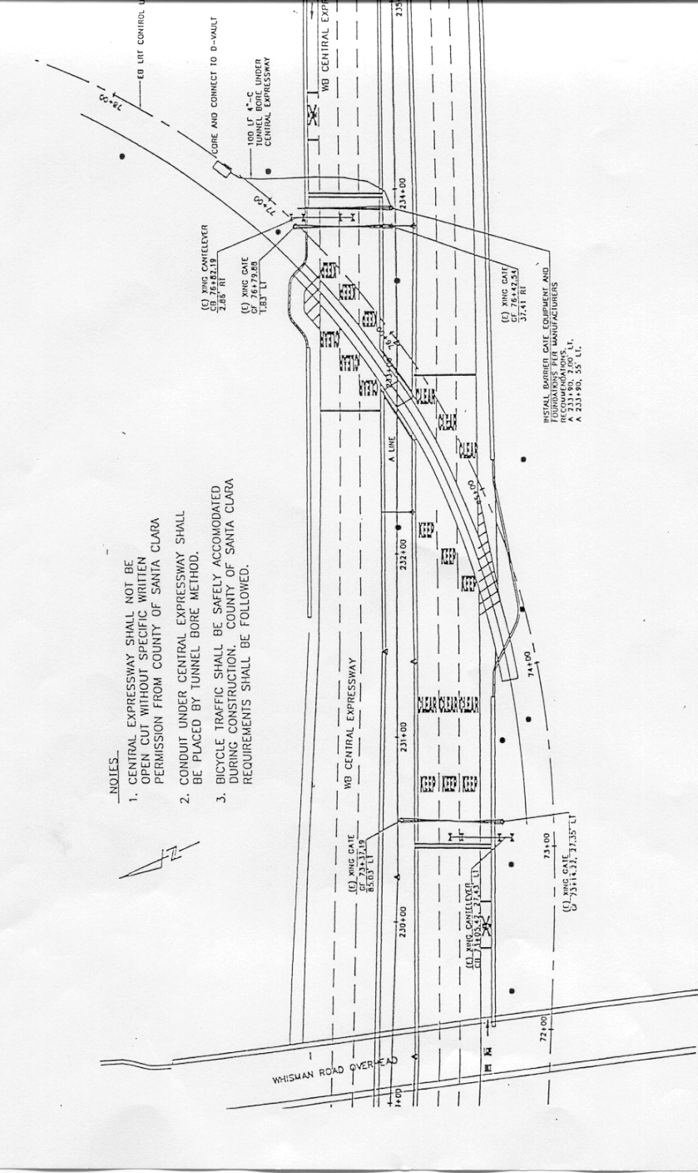
APPENDIX A
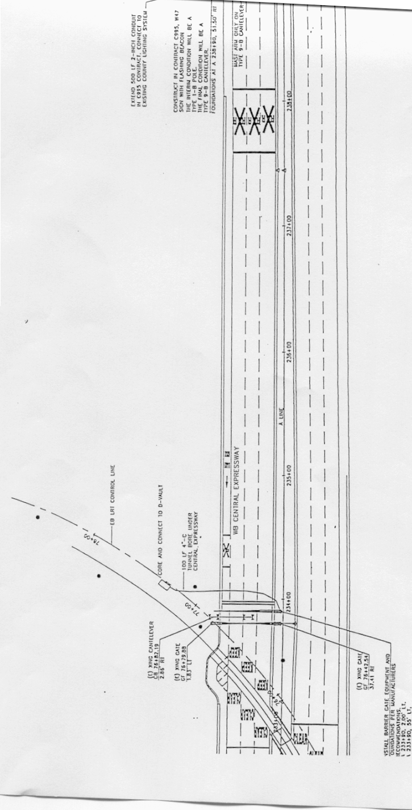
APPENDIX A (Continued)
APPENDIX B
DESCRIPTION & DRAWING OF THE POSITIVE-BARRIER GATE

Safety Barrier Gate Description
(as described in Exhibit L1 of the Amendment to A.94-12-018)

B&B Electromatic in Norwood, Louisiana manufactures the movable safety barrier gate. The safety barrier gate arm is deployed using a vertical pivot action, with a positive locking device at each end of the arm to secure the gate across the roadway. The locking device at the far end of the gate arm is located behind the roadway shoulder. It is mounted in a concrete foundation.

Energy absorption steel cables internal to the gate arm tubing enable the B&B safety barrier gate to arrest a vehicle. The purpose of the safety barrier gate is to stop the vehicle prior to the railroad tracks, thus preventing a collision between the vehicle and the train.

The safety barrier is a moveable gate intended to close a roadway temporarily at a railroad crossing. It consists of a housing containing the electro-mechanical components that lower and raise the arm. The arm is comprised of three 19-mm diameter steel cables. The top and bottom cables are set inside two 90-mm diameter Schedule 40 aluminum tubes which are connected by twenty-two 380 mm long rectangular connectors welded vertically between the upper and lower tubes. Three separate 8.5 diameter cables are threaded through each of these vertical connectors t o join the upper, middle and lower energy absorbing 19-mm cables to hold them in place in a crash.

When the gate is in its closed position, the cables and aluminum framework fit into two endlock assemblies that are bolted to concrete foundations on both sides of the roadway. The center of the lowest tube is 375 mm above the pavement surface and the center of the top tube is 730 mm above ground when the barrier is down. Total gate width is 13.7 meters.

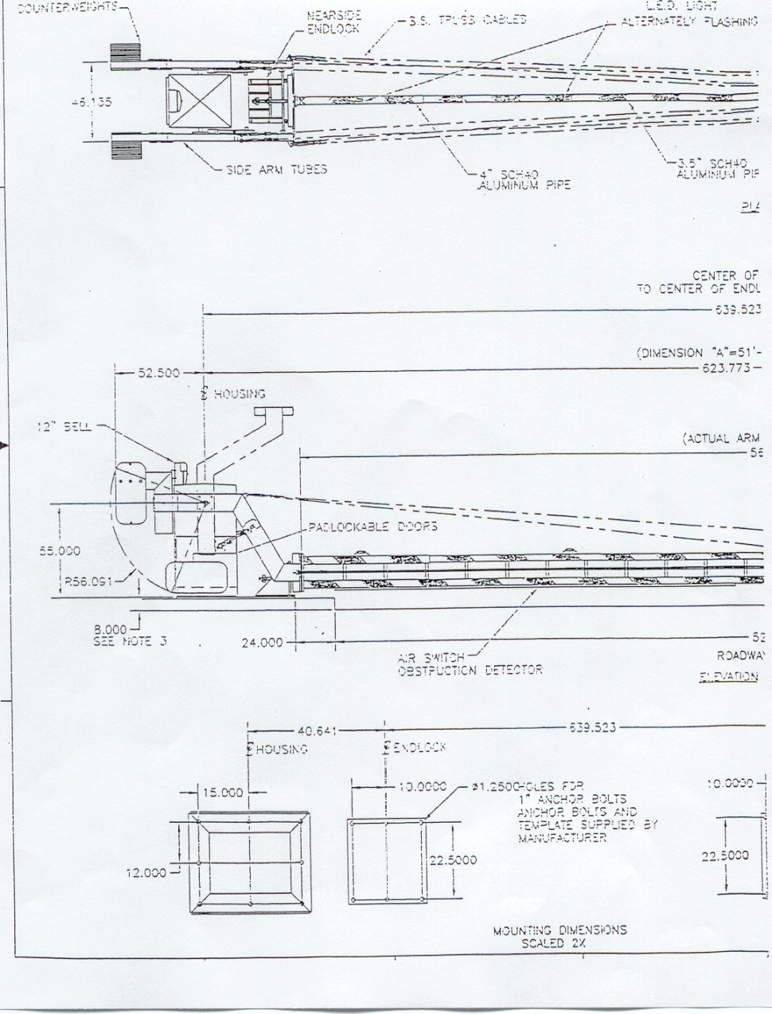APPENDIX B

APPENDIX B (Continued)
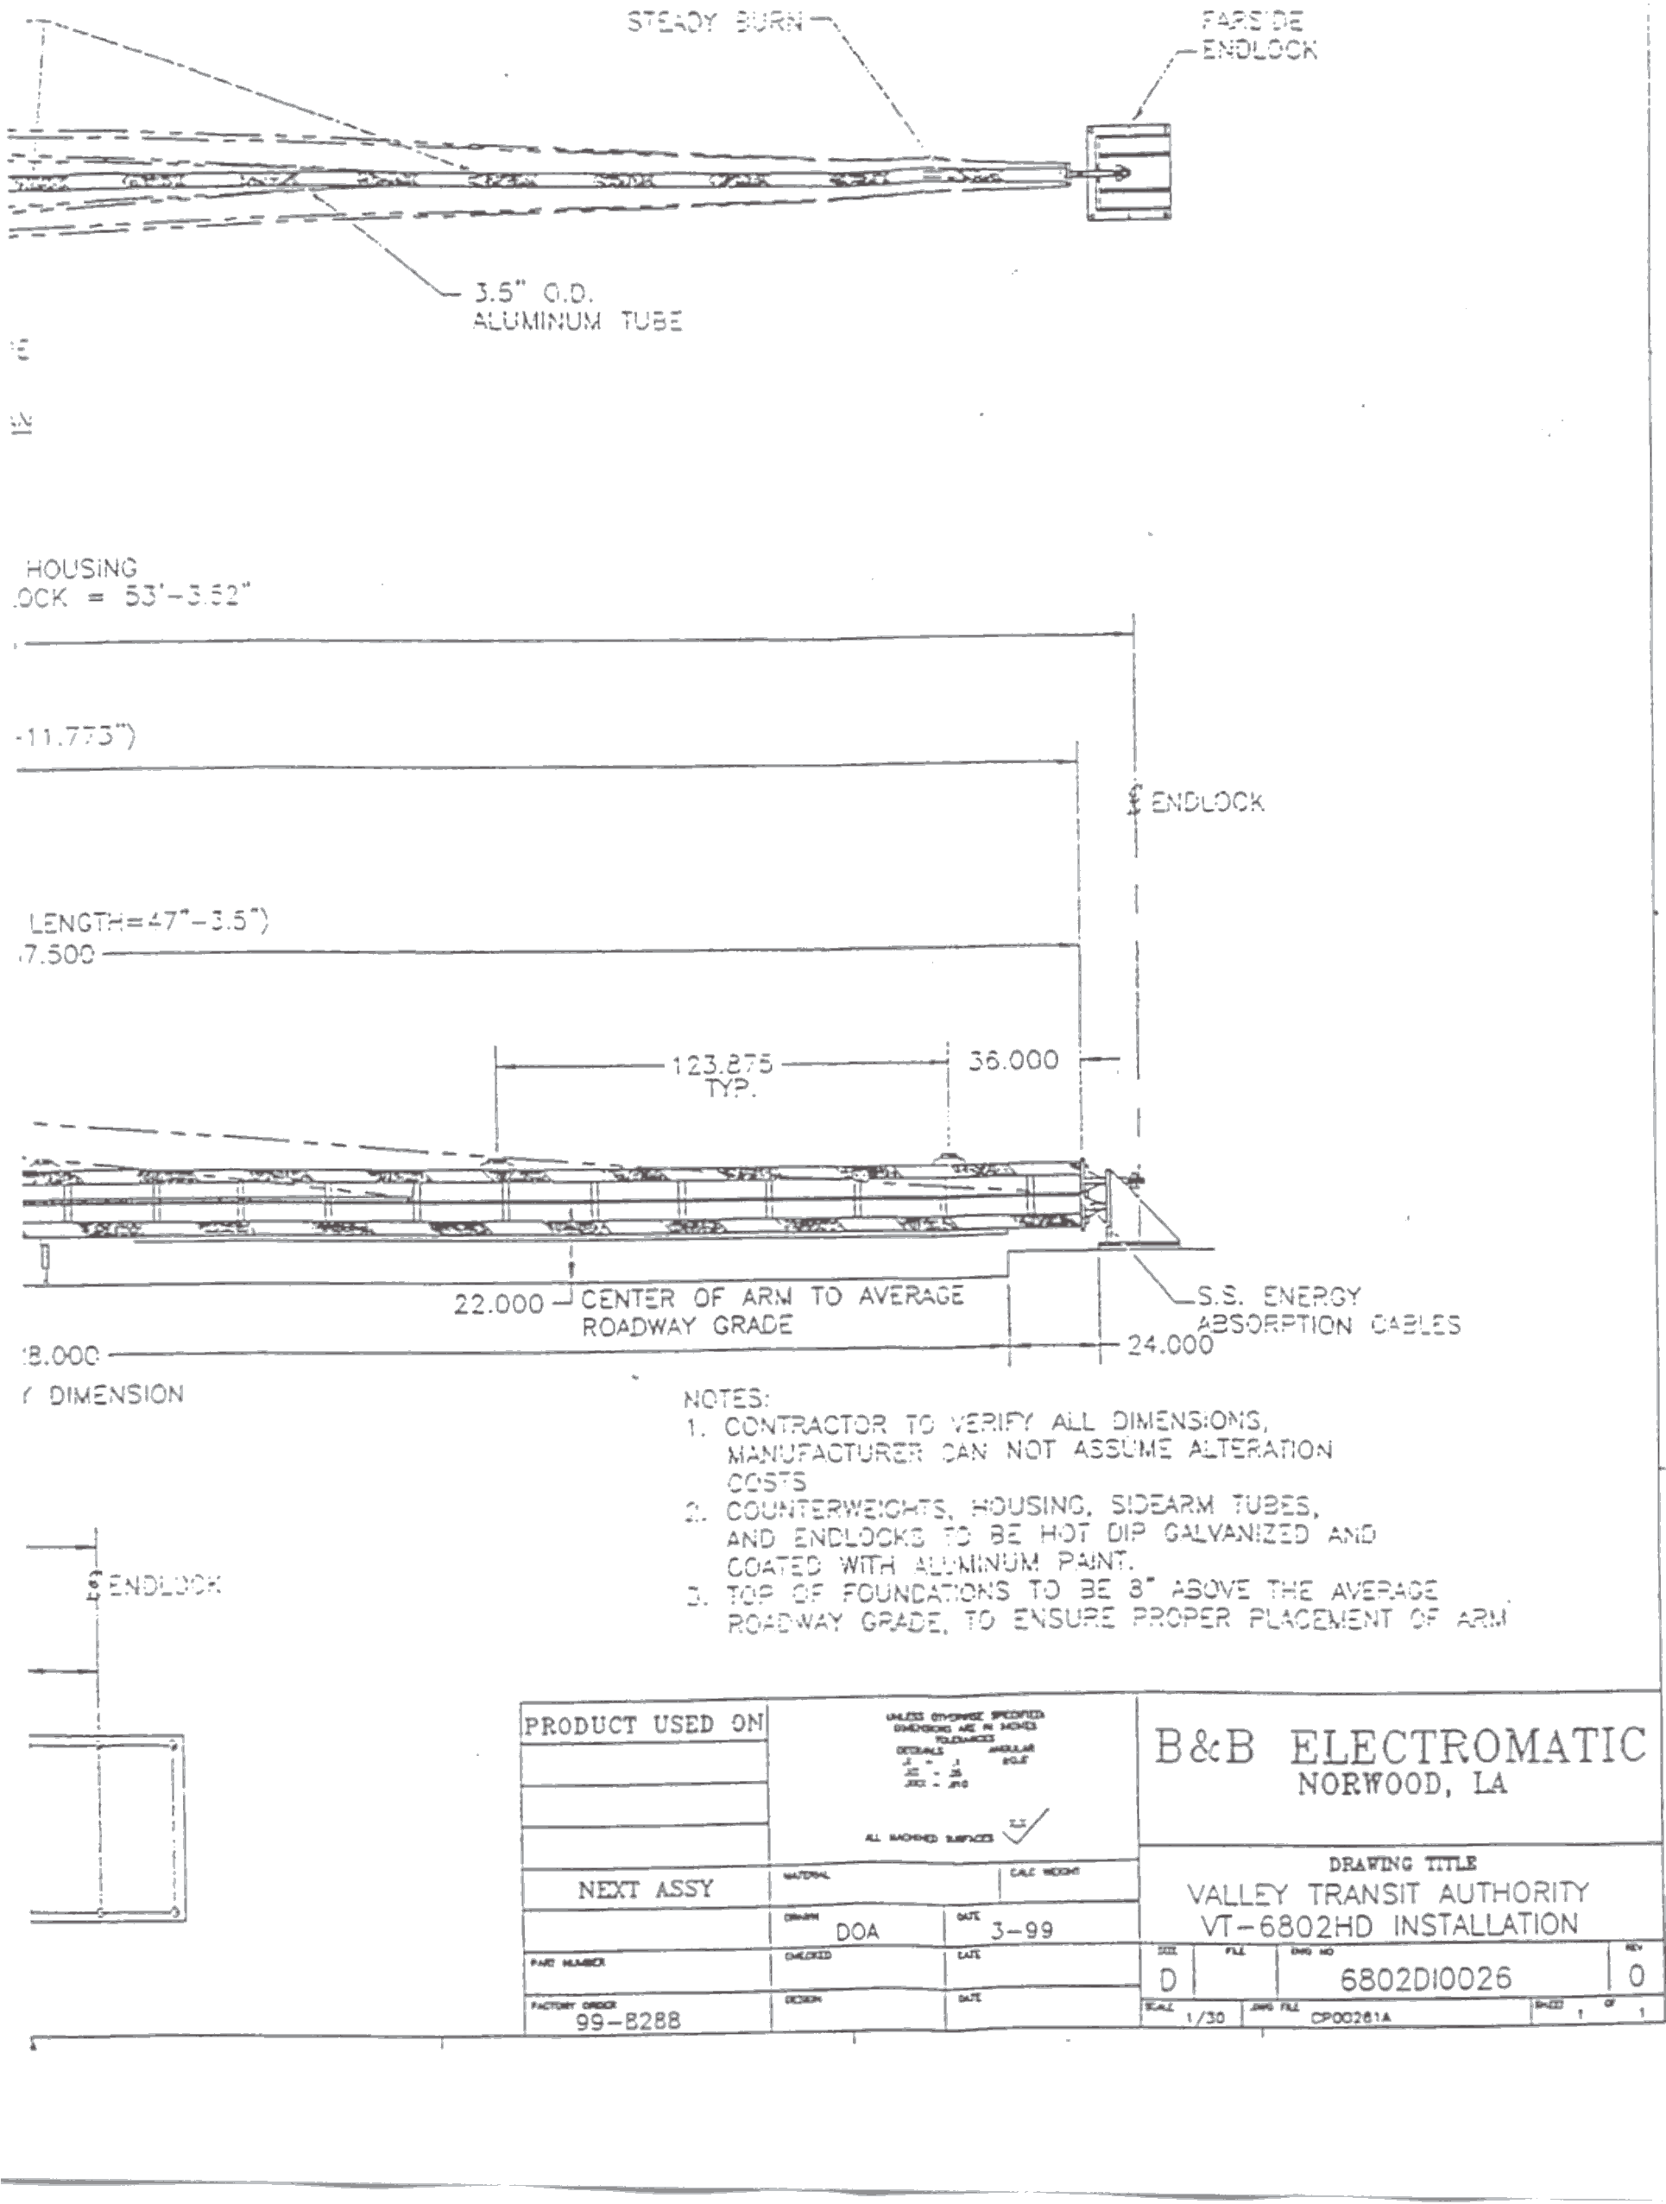
APPENDIX C
BARRIER GATE OPERATIONS & MAINTENANCE, TESTING & EVALUATION
(as described in Exhibit L1 of the Amendment to A.98-12-018)

Operations & Maintenance

The safety barrier gate will begin its downward cycle at the same time as the lights begin to flash on the conventional railroad gates. The gate will be down in 17 seconds from the initial descent. The safety barrier gate will be activated in the same manner as the conventional crossing gate, using fail safe relays and the battery backup.

If the safety barrier gate should be struck by a vehicle and be damaged, VTA maintenance staff will be dispatched to the Central Expressway crossing. They will clean up the broken gate and vehicle components, leaving the conventional railroad gate to provide safety at the grade crossing. The immediate goal of the maintenance staff is to clear the roadway of debris, allowing motorists to proceed safely along Central Expressway.

When train operators are advised of, or observe, broken crossing gates (including the safety barrier gate), their trains must be stopped prior to the grade crossing. An audible horn signal must be given, and the train shall proceed when it is safe to do so (VTA SOP #3.5).

During light activity for the roadway and LRT (weekends and late evenings), the maintenance crew will install the spare safety barrier gate. Flagmen will be present to guide motorists through the intersection. The new safety barrier gate will be replaced within five working days of the destruction of the original safety barrier gate. VTA will order a spare safety barrier gate and store it in San Jose at a VTA storage facility, available as a replacement if required.

If the traditional crossing gate is broken, VTA maintenance will follow existing broken gate procedures which specify that gate debris will be removed, a flagman will be immediately dispatched to the intersection, and the crossing gate repaired as soon as possible.

APPENDIX C, (continued)

Testing & Evaluation

Once the advance warning sign, the safety barrier gate and the crossing traffic control devices are installed, it will be important to evaluate motorist reaction and behavior at this grade crossing. Motorists are accustomed to railroad gates at railroad crossings. Risky behavior of going under or around gates to “beat the train” is well documented. However, documentation does not exist on driver reaction to barrier gates.

The evaluation will focus on the change in driver behavior resulting from the installation of the safety barrier gate system. It will measure the effectiveness of the gate in reducing the number of safety violations (near misses) occurring after the grade crossing warning signals are activated.

In addition, signal maintainer’s concerns will be evaluated, interviews of LRT employees and motorists will be conducted, and movements observed on video. In the event that a collision occurs between a vehicle and the barrier gate, a detailed evaluation of all aspects of the collision, including the clean-up and replacement of the damaged gate arm, will be provided.

Videos will be taken of the westbound approach to the Central Expressway crossing. The important observation will be to evaluate their reaction to the advance sign, i.e. speed reduction, and to the barrier itself. In addition, it will be important to record any intrusion into the safety barrier.

6-Month Preliminary Evaluation Report (due six months after installation)
A six-month “Preliminary Evaluation Report” will be prepared. This report will evaluate progress to date, identify problem areas, problem solution, and reactions of LRT employees and motorists.

1-Year Final Report (due 1 year after installation)
The trial installation will be in effect for a period of one year from the date of installation into the ground. After one full year of operation, a Final Evaluation Report will be prepared.

1-Month Post Incident Report (due 1 month after each intrusion)
If there is an intrusion into the safety barrier gate, an analysis will be conducted on this event and submitted to the CPUC within one month of its occurrence. This analysis will evaluate the effects of the intrusion into the gate in the following areas: disruption to vehicular traffic, disruption to LRT service, flagging operations, severity of any injuries sustained, timing of the accident, arrival of clean-up crew and the clean-up process, installation of the replacement gate, etc.

NOTE: If at any time, the positive-barrier gate system is deemed insufficient, inadequate, or unsafe, and subsequently removed from operation, VTA shall mitigate hazards associated with the limited sight-triangle in order to maintain operations across Central Expressway.

Initial installation will consist of two Caltrans Type 1B signs; roadside mount. Final installation of the Type 9B is expected by January 2000.
As part of its energy-absorption design, the gate shatters upon vehicular intrusion while the foundations, locking plates, and motor remain isolated. VTA will maintain a spare gate for expedient replacement, should it be needed (see Appendix C of this Decision).
“Safety barrier gate” is synonymous with the term “positive-barrier gate” as used throughout this Decision.

